CONFIDENTIAL
DECLARATION FORM
From,
Madhu Kumar Balusu Date: 09/16/2025

Sub: Gap Declaration for employment / education
To,
HR Manager,

Respected Sir,
I would like to bring to your notice that I Do not have any following gap in my education / employment.
Sl No. | Education / Employment details | Gap difference in months & years of gap | Justification for Education / Employment Gap | Documents if any
1 | Post Education Gap | 4 months | Job Search | NA
2
3
4
I declare that the above information mentioned is true to the best of my knowledge.

Yours Faithfully,
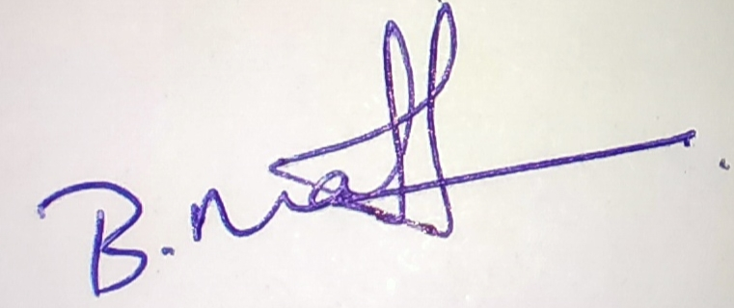

Signatory

